Mellon Collie And The Infinite Sadness

Git-Hub Repository

Resizing Video

Brief
I am making a website about my favourite album, “Mellon Collie And The Infinite Sadness”, which is as much a showcase as it is a listening experience. Ideally, a user would be able to listen along to the album as they advance through my website. Since I am limited to a single page, I will be having to swap out a lot of elements with one another in order to achieve a fresh look for each of the 28 songs. As I am aware this is a large task, I likely will not be finishing my website, since it's smart to stop when I think I have shown off the relevant skills. Where possible, I will develop my website so that anyone could continue it at a later date. However, I suspect it would be better to switch to a multiple page setup if one were to do this.

Design

A clear description of how your Multi-Device Application deploys established responsive web design principles. You should outline and justify your design decisions, including how your design differs between mobile, tablet, and desktop

My website will be responsive to different screen sizes. To achieve this, I generally used % or vw units for widths. Then, at certain intervals, I used media queries in order to adapt the site when it can no longer cope at the extreme of the last measurement. This means my website can be resized with little to no issues, and will adapt its content to always be accessible to the user.

On different screen sizes, the content in the main body is adjusted in order to best fit the view. I used a grid to accomplish this as I thought a lot of the items would need to be stacked near one another. Furthermore, I would be able to add additional content to the grid more easily and not worry about the CSS as it should automatically be applied.

Unfortunately, when I was designing the website it was the easiest and quickest way sometimes to use set pixel widths. This, as well as a lot of HTML elements being layered on top of one another, ensures that it is really difficult to change the website without changing many elements, which is time consuming. This means the website is not as responsive as I’d hope. Specifically in the sun-and-moon content area, where it looks bad on larger screen sizes.

I used JavaScript in order to accomplish most of the behind the scenes happenings on the website. This means the performance of the website is very good and very fast on most modern browsers. Furthermore, I believe my HTML items are used correctly, and I have used divs in order to make the code more readable (although some of the names are not the best).

Navigation is very important to me and any potential users. The task restricts me to a single web page, so in order to still have some semblance of navigation, I used a tracker to tell the user where they are within the album. This is in the form of the sun/moon which is significant and takes up a lot of the screen. It is important to me that a user grasps what is going on here, so I tried using a skeuomorphic based design with the cord on the right hand side of the screen. This should make it obvious that users can “pull” the chord and it will do something, in my case, start playing the album. These have been with me since the start of the design, and are the core of the website.

Implementation

I started by outlining what I had thought of for my website on pen and paper. You can see from these images below the initial idea for the main screen, as well as an idea for the animation which would play when the user “pulls” the cord. In the end, I am happy with how close this was to my actual website.
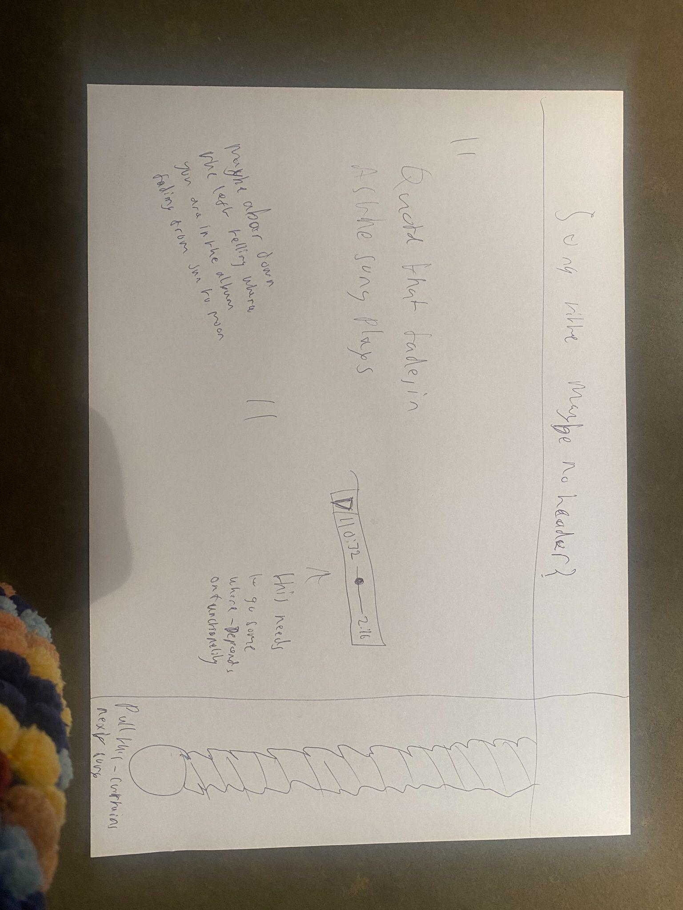
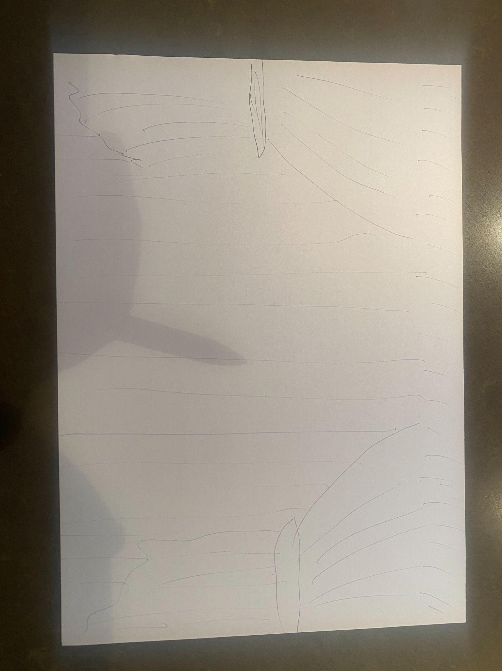
After this, I went to Lucidchart to develop some actual renders of what it could look like. Again, I am very happy with how these turned out compared to the website. You can see these renders below.

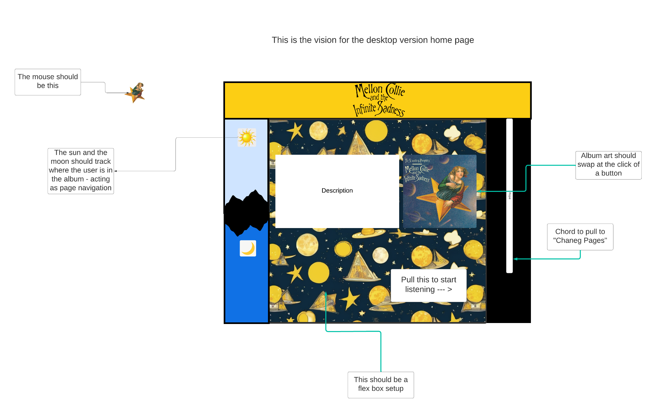
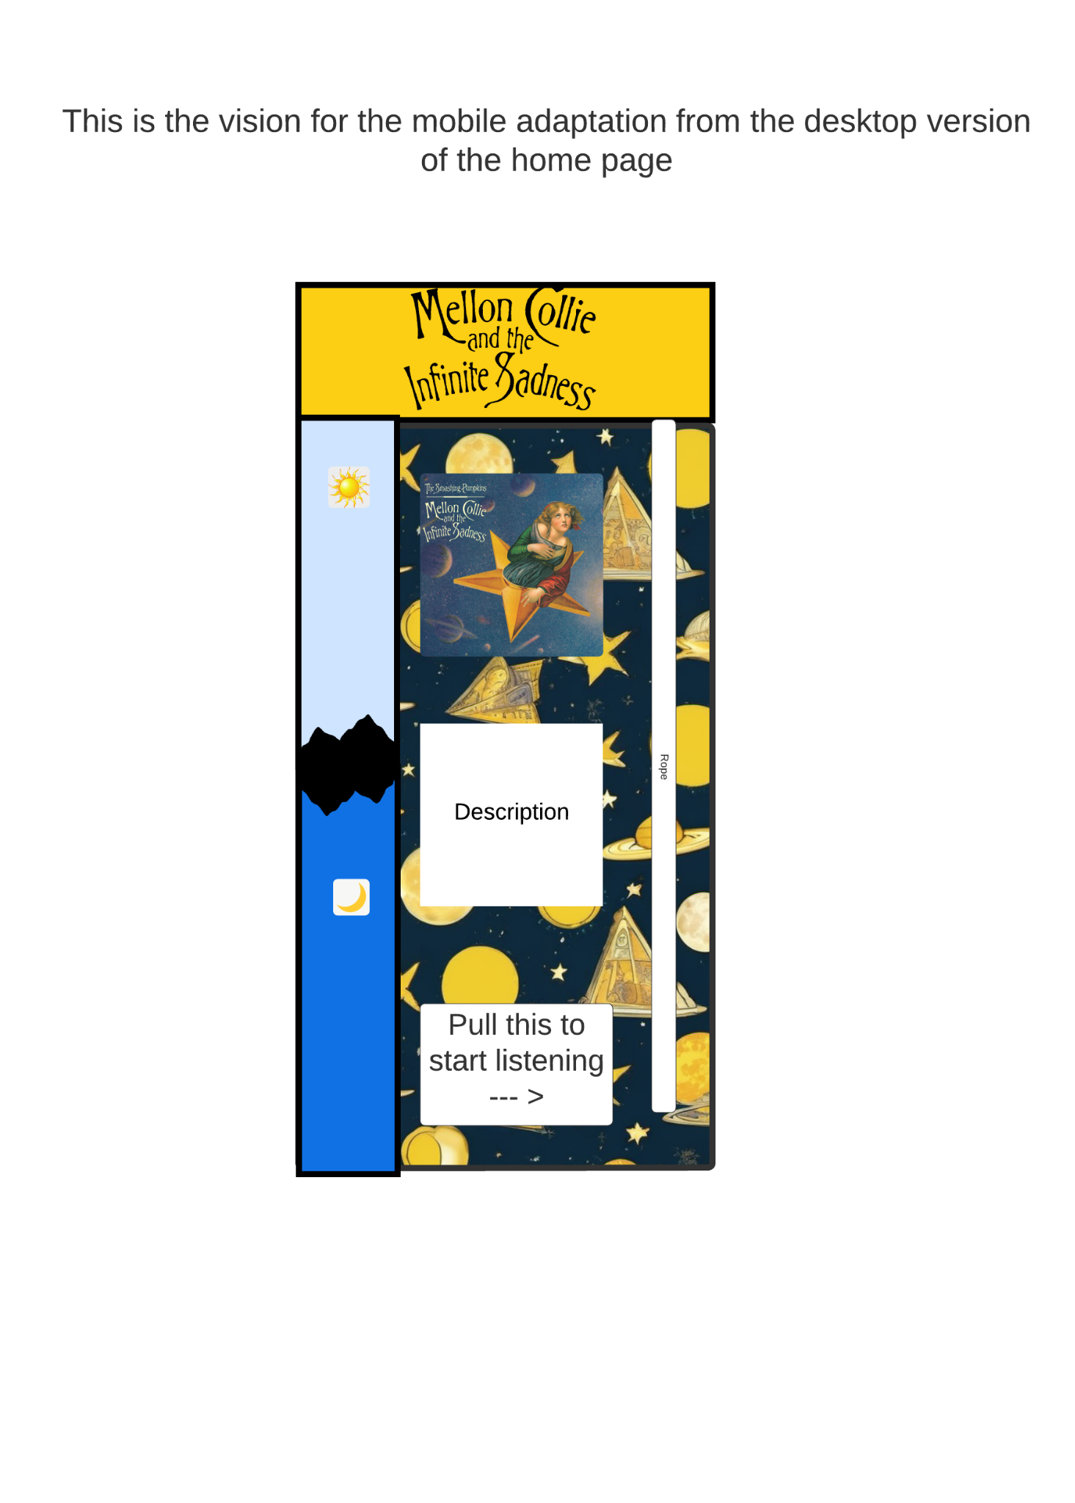
Once I had this, I started working on the code. The HTML and CSS was all very simple, and didn’t include anything specifically noteworthy. I used the way the boxes were laid out here in order to dictate my divs and then put the content in them as required. Therefore, below you will see me working on some JavaScript.

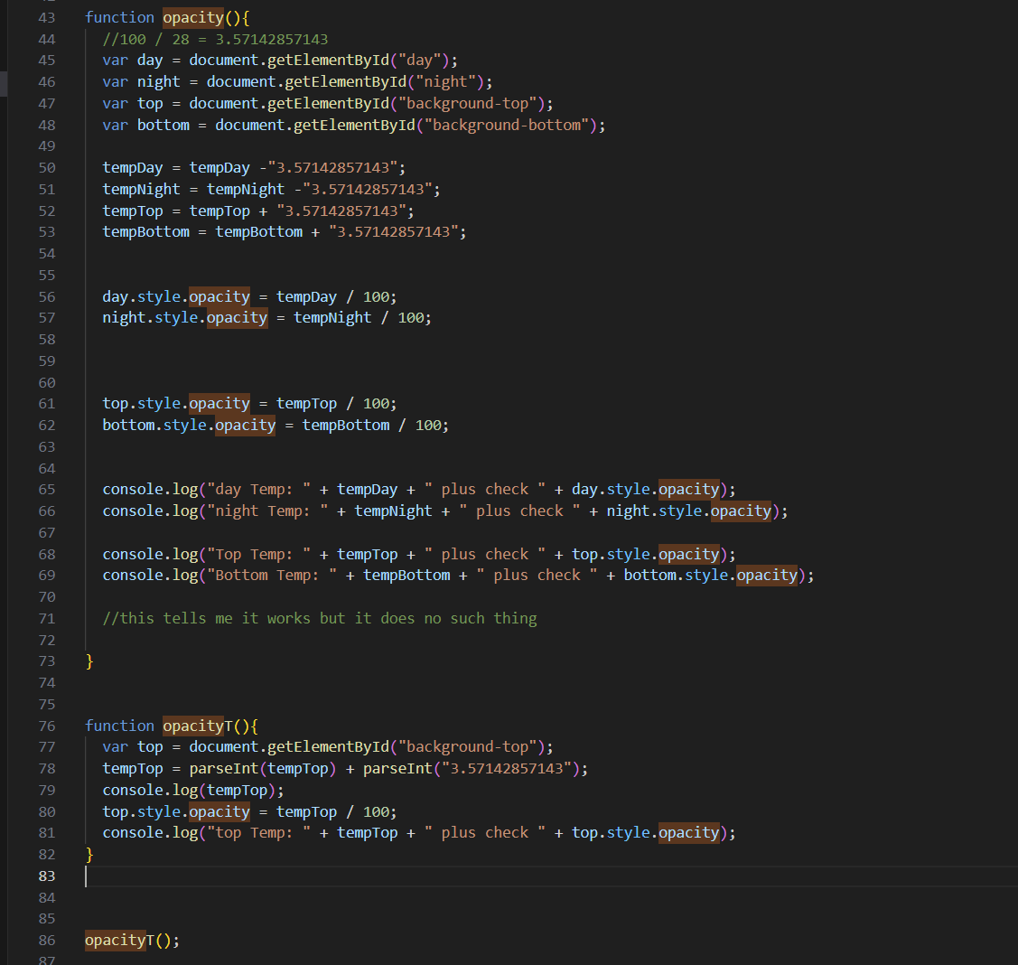

Here you can see I used this opacityT (temp) to find out why the opacity isn't working. The problem was that Javascript uses + as concatenation and addition. I isolated one of the 4 aspects which needed changing and was able to figure this out with the help of a quick google search. I changed the code to include parseInt, on line 78 here, and when it worked I was able to do the same in the real opacity function.

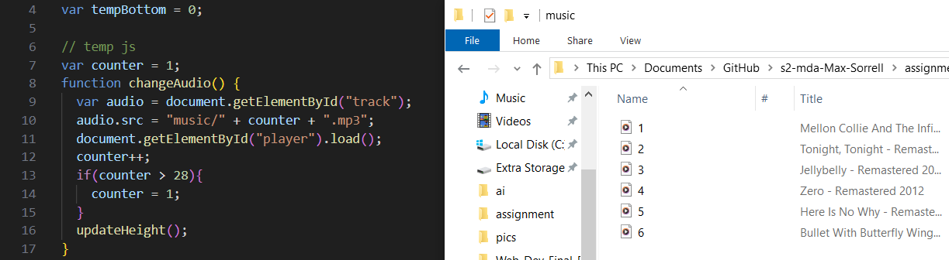

The way I have my code set up here shows that in order to add new songs I only need to rename the song and don't have to touch the code at all. This is due to the fact that I used a variable which loops through each button click in order to dictate what the src of the element needs to be. This saved me a lot of time.

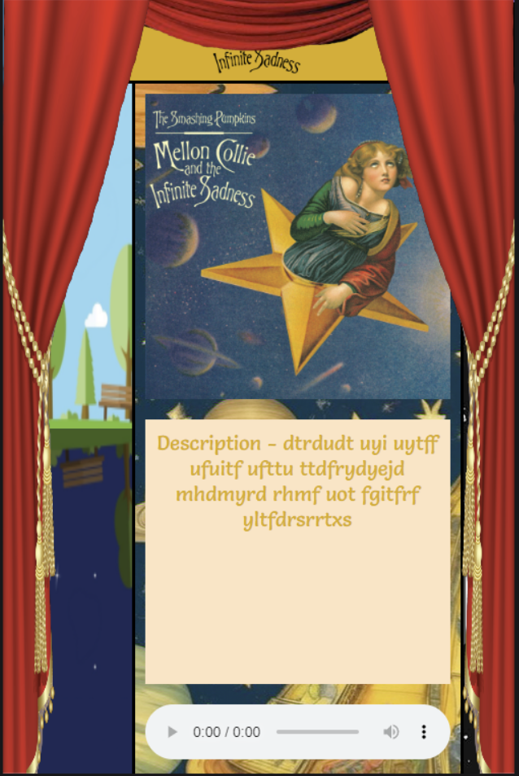
This is something I wanted to work on but don’t think I will have enough time for. Conceptually, it was an animation which would play each time the rope is pulled, giving a curtain's closing and reopening effect. This was my idea from the very start of the project, as you will be able to tell with the rope pull button being an integral component to other aspects of the website. The reason I am not going to implement this is because at this current time I still have not focused on the centre of the website and delving into animations seems like it could completely drain all of my time. Some of the features this animation would have consisted of are:

- Animation which plays when the rope is pulled (button is clicked).
- Curtains visible at all times on displays which have more room.
- A time delay on objects which need to refresh so that the curtain animation can play, objects change, and then the curtains can be withdrawn via another animation (or the reverse of the same animation).

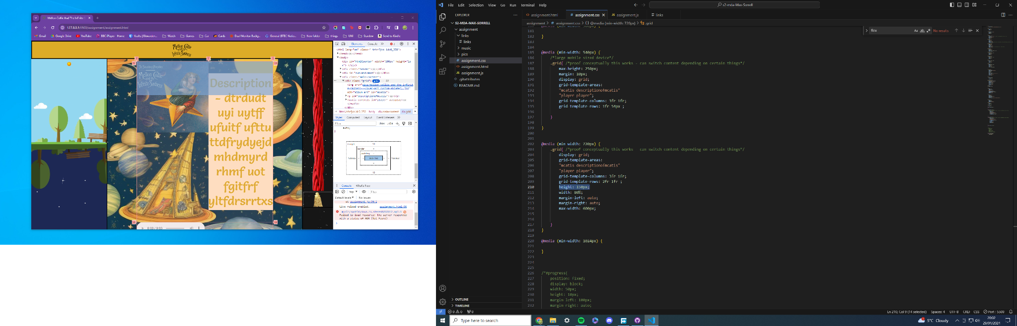

Here you can see me struggling with the grid layout. For some reason, items will not stay within the grid, so even when I set the height to a specific pixel value, all my items are not on the screen. This works fine for the width though so perhaps grid is not what I need to use.

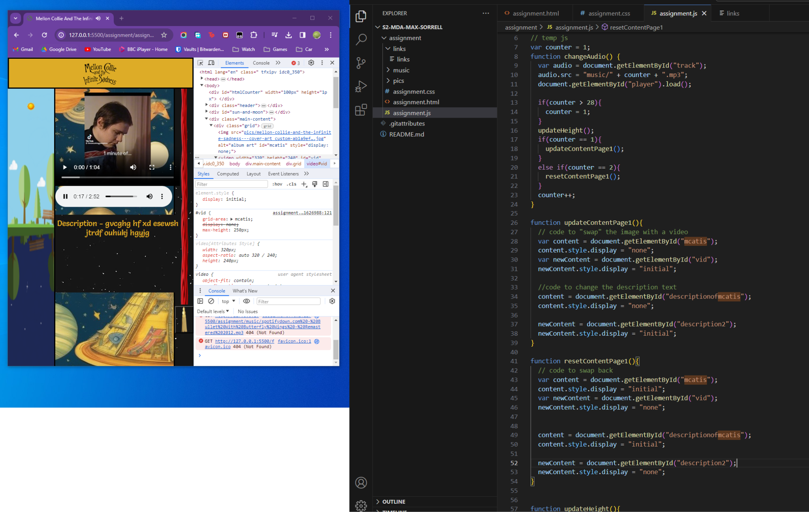

This is the code I used in order to swap around screen elements. This code is not great because each time I want to change a screen I need to write a lot of Javascript. However, the way that the CSS is setup allows me to only change a few things and keep the style the same. This is great because I am able to swap elements out really easily. Of course, if I had the time I would create a nice page for each song, but since there are 28 songs and I am not marked on the content of the website, I thought it best to leave it here since I have proven it could be done. Ideally, the Javascript would loop through like the music counter does to pick a track. However, my ability to do this would entirely depend on the content I want on each page.

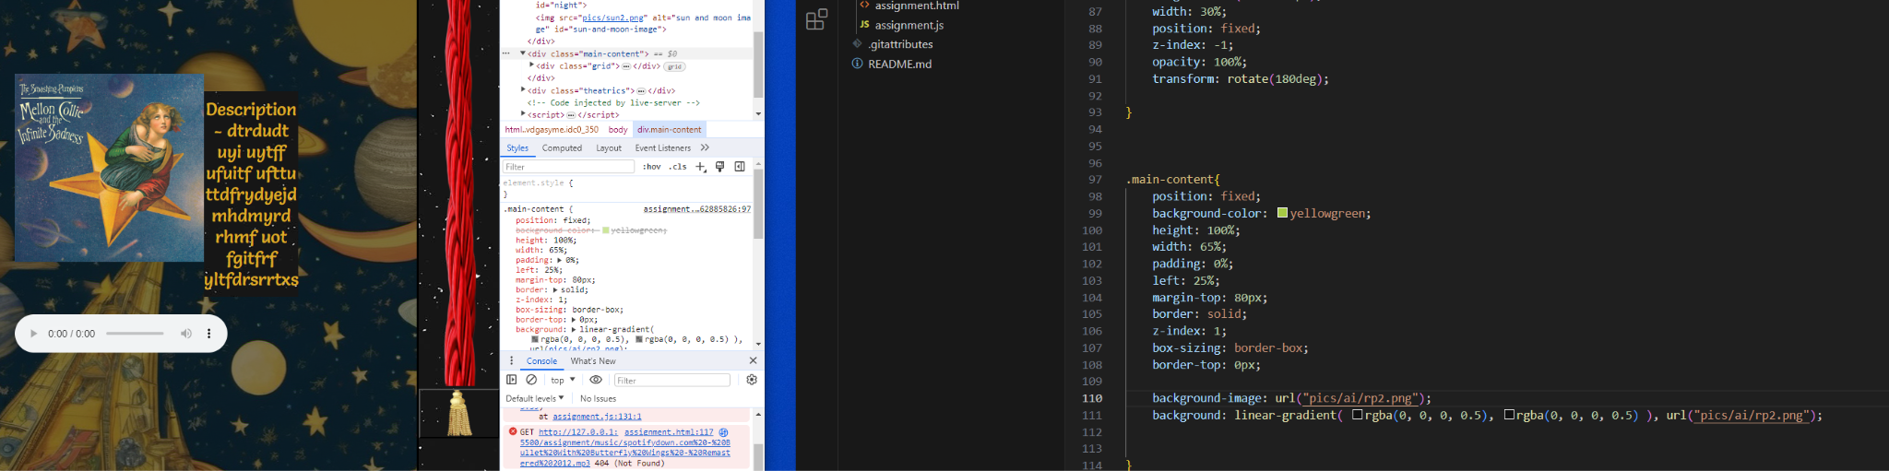
Throughout the project, I have been distracted by the background of the website. I was under the impression I could not change the opacity, since when I did using “opacity: 50%;”, it set the opacity for the entire main. Then, I found out you could achieve what I was after by using the CSS line I found here. This was great and I think it really helps the user focus on the actual content in the main body of the website. The content pops out now where before it merged in and looked messy.

In an attempt to offer users as much choice as possible, I have now set this to dynamically apply depending on whether or not the user is in dark mode.

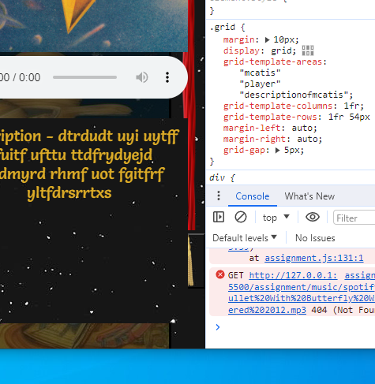

Here you can see me running into an issue with the grid layout again. The website overlaps itself when the screen size is too small. To solve this, since I’ve no time to fully perfect the grid layout, I simply ensured the button was always accessible by adding a z-axis to its CSS. I don’t particularly like the look of this since the background overlaps the content. However, I believe it is in the users best interest to keep the accessibility of my website as the top priority.

Critical Reflection

Overall, I would say my website succeeds in what it sets out to accomplish. It is a responsive, interactive site which demonstrates what I was after and shows off something which I am very passionate about. I have evaluated most aspects as I went, but generally I am happy with it. I like that I am able to listen to the album on my website. I like the look of it, as it reminds me a lot of the album and its themes.

Unfortunately, the website is not finished, since only a couple pages show different content. The content itself is lacking since it is not what I was focusing on. This means the actual usability of the website is not great, in terms of if someone would actually use it to listen along to the album as an experience. Functionally, I think this means it works more of a concept than a fully fleshed out website.

I think the best thing about the website is how it adapts to not having more than one page. The use of JavaScript to control the different elements was great and something I haven't done before.

In order to refine my skills, I need to learn more about grid, and how it works. I think it lets my website down here, since the positioning of the elements in the main is far from perfect and even though it works it looks haphazard and messy. This is sort of intentional, since it is following themes of the album, and an organised main part of the website would look counterintuitive. However, I think if I could find that middle ground, perhaps by exploring something other than grid layout, I think it would work very nicely.

Furthermore, I believe I have made improvements in my HTML and CSS layouts in terms of the actual script. I think the way it is laid out is clear and everything is in the right place. I’m not 100% sure about the JavaScript, since it’s my first time using it so there's very little I have to compare it to. Hopefully, the readability of my code will help you to understand it.

Note
Please see files within code folder to download other items such as:
- Video of website being resized
- Text file with links which I used and how they were helpful
- LucidChart designs

